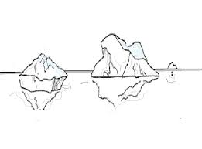Aghe glaçade in aghe licuide

Met un cubet di glace intun contignidôr di aghe.

Prove ancje cun formis di glace diferentis.

|  |  |  |  |  |  |  |
| --- | --- | --- | --- | --- | --- | --- |
| **Cubet di glace**  (forme) | **Prevision:**  flotaraial o no? | |  | **Esperiment:**  flotial o no? | | **Controle la tô prevision:** âstu induvinât? |
| Cubi | si | no |  | si | no |  |
| Iregolâr | si | no |  | si | no |  |
| Cûr | si | no |  | si | no |  |
| Taront | si | no |  | si | no |  |
| Altri | si | no |  | si | no |  |

Ce sucedial?

__________________________________________________________________________________________________________________________________

**Par aprofondî**

Tu puedis colegâti ai links chi sot.

<https://www.youtube.com/watch?v=blMb9nbCvq4>

<https://www.youtube.com/watch?v=xwyVux3nLb4>

**Conclusion:**

O ai osservât che la glace ________________________________________________________________________________________________________________________________________________________________________